DePaul Android Application
Test Plan
V- 1.0
V

Document Change History
Version Number | Date | Contributor | Description
D-0.1 | 11/03/2010 | Limor Marco | Initial draft
V1.0 | 11/07/2010 | Limor Marco | Update after review comments

Table of Contents

1 Introduction 3
1.1 Scope 3
1.1.1 In Scope 3
1.1.2 Out of Scope 3
1.2 Quality Objective 4
1.2.1 Primary Objective 4
1.2.2 Secondary Objective 4
1.3 Roles and Responsibilities 4
1.3.1 Developer 4
1.3.2 Tester 4
1.3.3 Testing Lead 5
1.4 Assumptions for Test Execution 5
1.5 Constraints for Test Execution 5
1.6 Definitions 5
2 Test Methodology 6
2.1 Purpose 6
2.1.1 Overview 6
2.1.2 Usability Testing 6
2.1.3 Unit Testing (Junit) 6
2.1.4 Iteration/Regression Testing 7
2.1.5 Final release Testing 7
2.1.6 Testing completeness Criteria 7
2.2 Bug Regression 9
2.3 Bug Triage 9
2.4 Test Completeness 9
2.4.1 Standard Conditions: 9
3 Test Deliverables 10
3.1 Deliverables Matrix 11
3.2 Documents 11
3.2.1 Test Plan 11
3.2.2 Test Suite Document 11
3.2.3 Requirements Traceability Matrix 12
3.3 Defect Tracking & Debugging 12
3.3.1 Defect reporting using JIRA 12
3.4 Reports 13
3.4.1 Testing status reports 13
3.4.2 Phase Completion Reports 13
3.4.3 Test Final Report - Sign-Off 14
3.5 Responsibility Matrix 14
4 Resource & Environment Needs 15
4.1 Testing Tools 15
4.1.1 Tracking Tools 15
4.1.1.1 Configuration Management 15
4.2 Test Environment 15
4.2.1 Hardware 15
4.2.2 Software 15
4.3 Bug Severity and Priority Definition 15
4.3.1 Severity List 15
4.3.2 Priority List 16
4.4 Bug Reporting 16
5 Terms/Acronyms 18

Introduction
This test approach document describes the appropriate strategies, process, workflows and methodologies used to plan, organize, execute and manage testing of the DePaul Android application project.

Software testing, depending on the testing method employed, can be implemented at any time in the development process. However, most of the test effort occurs after the requirements have been defined and the coding process has been completed. As such, the methodology of the test is governed by the software development methodology adopted.

Scope

Software testing is an investigation conducted to provide stakeholders with information about the quality of the product or service under test. Software testing also provides an objective, independent view of the software to allow the business to appreciate and understand the risks at implementation of the software. Test techniques include, but are not limited to, the process of executing a program or application with the intent of finding software bugs.
Software testing can also be stated as the process of validating and verifying that a software program/application/product:
- Meets the business and technical requirements that guided its design and development;
- Works as expected; and
- Can be implemented with the same characteristics.

In Scope
The DePaul Android application Test Plan defines the unit, integration, system, regression, and Client Acceptance testing approach. The test scope includes the following:
- Testing of all functional, application performance and use cases requirements listed in the requirement document.
- Quality requirements and fit metrics<DePaul Android Application >.
- End-to-end testing and testing of interfaces of all systems that interact with the < DePaul Android Application >.

Out of Scope
The following are considered out of scope for DePaul Android application system Test Plan and testing scope:
- Functional requirements testing for systems outside DePaul Android application.

Quality Objective

Primary Objective
A primary objective of testing application systems is to: assure that the system meets the full requirements, including quality requirements (AKA: Non-functional requirements) and fit metrics for each quality requirement and satisfies the use case scenarios and maintain the quality of the product. At the end of the project development cycle, the user should find that the project has met or exceeded all of their expectations as detailed in the requirements.

Any changes, additions, or deletions to the requirements document, Functional Specification, or Design Specification will be documented and tested at the highest level of quality allowed within the remaining time of the project and within the ability of the test team.

Secondary Objective
The secondary objective of testing application systems will be to: identify and expose all issues and associated risks, communicate all known issues to the project team, and ensure that all issues are addressed in an appropriate matter before release. As an objective, this requires careful and methodical testing of the application to first ensure all areas of the system are scrutinized and, consequently, all issues (bugs) found are dealt with appropriately.

Roles and Responsibilities

Developer
Responsible to:
(a) Develop the system/application
(b) Develop Use cases and requirements in collaboration with the Adopters
(c) Conduct Unit testing
(d) Support system, regression, integration and user acceptance testing

Tester
Responsible to:
(a) Contribute to Use case, requirement development through review
(b) Contribute to develop and execution of the development test scripts through review
(c) Conduct Full User Acceptance, regression, and end-to-end testing; this includes identifying testing scenarios, building the test scripts, executing scripts and reporting test results

Testing Lead
The project manager responsible to manage the entire testing process, workflow and quality management with activities and responsibilities to:

(a) Monitor and manage testing integrity and Support testing activities
(b) Coordinate activities across the project

Assumptions for Test Execution

- For User Acceptance testing, the Developer team has completed unit, system and integration testing and met all the Requirement’s (including quality requirements) based on Requirement Traceability Matrix.
- User Acceptance testing will be conducted by End-users
- Test results will be reported on daily basis.
- Test scripts/cases are developed and approved.
- Tester will support and provide appropriate guidance to Adopters and Developers to conduct testing

Constraints for Test Execution
- Developer will support ongoing testing activities based on priorities
- The Developer cannot execute the User Acceptance and End to End test scripts. After debugging, the developer can conduct their internal test, but no results from that test can be recorded / reported.

Definitions
Bugs: Any error or defect that cause the software/application or hardware to malfunction. That is also included in the requirements and does not meet the required workflow, process or function point.

Enhancement:
1) Any alteration or modification to the existing system for better workflow and process.
2) An error or defect that causes the software/application or hardware to malfunction.
Where 1) and 2) is NOT included in the requirements can be categorized as an enhancement.

Enhancement can be added as a new requirement after appropriate Change Management process.

Test Methodology

Purpose

Overview
The purpose of the Test Plan is to achieve the following:
- Define testing strategies for each area and sub-area to include all the functional and quality (non-functional) requirements.
- Define bug-tracking procedures.
- Identify testing risks.
- Identify required resources and related information.
- Provide testing Schedule.

Usability Testing
The purpose of usability testing is to ensure that the new components and features will function in a manner that is acceptable to the customer.
Development will typically create a non-functioning prototype of the UI components to evaluate the proposed design (as close to end-users as possible).

Unit Testing (Junit)

Unit testing will be written by the Developer during code development process to ensure that proper functionality and code coverage have been achieved by each developer both during coding and in preparation for acceptance into iterations testing.

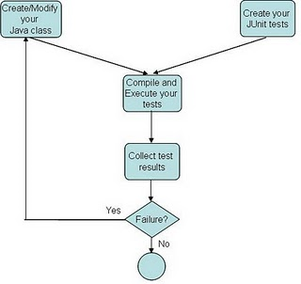
The popular JUnit test framework is integrated into Android. JUnit, if used properly, brings two major benefits to the test implementation.
JUnit enforces the hierarchical organization of the test cases
The pattern JUnit is based on guarantees the independence of the test cases and minimizes their interference.

Android uses JUnit, and open source framework for writing and running unit tests. Some of the framework's features are:
- Assertions for testing expected results
- Test fixtures for sharing common data
- Test runners for running tests

How does JUnit work? You use assert statements to assert that something is true (assertTrue(expected, actual), assertTrue(condition), etc), that something is false (assertFalse(condition), etc), that something is equal (assertEqual(expected, actual), etc). When an assert fails, the test failed for that particular case, hence your code needs to be fixed (assuming the unit test was written correctly).

Each developer Commit/Change to the Google code will trigger Junit testing targets. This would ensure that ever commit the unit tests are still working and will keep the code quality.

Iteration/Regression Testing
During the repeated cycles of identifying bugs and taking receipt of new builds (containing bug fix code changes), there are several processes which are common to this phase across all projects. These include the various types of tests: functionality, performance, stress, configuration, etc. There is also the process of communicating results from testing and ensuring that new drops/iterations contain stable fixes (regression). The project should plan for a minimum of 2-3 cycles of testing (drops/iterations of new builds).

At each iteration, a debriefing should be held. Specifically, the report must show that to the best degree achievable during the iteration testing phase, all identified severity 1 and severity 2 bugs have been communicated and addressed. At a minimum, all priority 1 and priority 2 bugs should be resolved prior to entering the beta phase.

Final release Testing
Assuming critical bugs are resolved during previous iterations testing- Throughout the Final Release test cycle, bug fixes will be focused on minor and trivial bugs (severity 3 and 4). Testing will continue its process of verifying the stability of the application through regression testing (existing known bugs, as well as existing test cases).

The milestone target of this phase is to establish that the application under test has reached a level of stability, appropriate for its usage (number users, etc.), that it can be released to the end users.

Testing completeness Criteria

The milestone target is to place the release/app (build) into production after it has been shown that the app has reached a level of stability that meets or exceeds the client expectations as defined in the Requirements, Functional Spec., and caBIG Production Standards.

Bug Regression
Bug Regression will be a central tenant throughout all testing phases.
All bugs that are resolved as “Fixed, Needs Re-Testing” will be regressed when the tester is notified of the new drop containing the fixes. When a bug passes regression it will be considered “Closed, Fixed”. If a bug fails regression, the tester will notify development team by entering notes into JIRA. The Tester will be responsible for tracking and reporting to development and product management the status of regression testing.

Bug Triage
Bug Triages will be held throughout all phases of the development cycle. Bug triages will be the responsibility of the PM. Triages will be held on a regular basis with the time frame being determined by the bug find rate and project schedules.
Thus, it would be typical to hold few triages during the Planning phase, then maybe one triage per week during the Design phase, ramping up to twice per week during the latter stages of the Development phase. Then, the Stabilization phase should see a substantial reduction in the number of new bugs found, thus a few triages per week would be the maximum (to deal with status on existing bugs).

All the team should all be involved in these triage meetings. The Test Lead will provide required documentation and reports on bugs for all attendees. The purpose of the triage is to determine the type of resolution for each bug and to prioritize and determine a schedule for all “To Be Fixed Bugs’. Development will then assign the bugs to the appropriate person for fixing and report the resolution of each bug back into the GForge bug tracker system. The Test Lead will be responsible for tracking and reporting on the status of all bug resolutions.

Test Completeness
Testing will be considered complete when the following conditions have been met:

Standard Conditions:
- When Adopters and Developers, agree that testing is complete, the app is stable, and agree that the application meets functional requirements.
- Script execution of all test cases in all areas have passed.
- Automated test cases have in all areas have passed.
- All priority 1 and 2 bugs have been resolved and closed.
- Ad hoc testing in all areas has been completed.

Test Deliverables

Testing will provide specific deliverables during the project. These deliverables fall into three basic categories: Documents, Test Cases / Bug Write-ups, and Reports. Here is a diagram indicating the dependencies of the various deliverables:

Require-
ments [PM]
Project Plan
[PM]
Functional
Spec [PM]
Test Plan
Test Spec.
/ Outline
Test
Cases
Bugs
Bug
Results
TC Coverage
Reports
Bug Reports
Weekly
Status
Reports
Test Case
Results

As the diagram above shows, there is a progression from one deliverable to the next. Each deliverable has its own dependencies, without which it is not possible to fully complete the deliverable.

The following page contains a matrix depicting all of the deliverables that Testing will use.

Deliverables Matrix

Deliverable
Documents
Test Approach
→ Test Plan
→ Test Schedule
→ Test Specifications
Test Case / Bug Write-Ups
Test Cases / Results
Test Coverage Reports
Jira reports for bug reporting
Reports
Test results report
Test Final Report - Sign-Off

Documents

Test Plan
The purpose of the Test Plan document is to:
- Specify the approach that Testing will use to test the product, and the deliverables (extract from the Test Approach).
- Break the product down into distinct areas and identify features of the product that are to be tested.
- Specify the procedures to be used for testing sign-off and product release.
- Indicate the tools used to test the product.
- List the resource and scheduling plans.
- Indicate the contact persons responsible for various areas of the project.
- Identify risks and contingency plans that may impact the testing of the product.
- Specify bug management procedures for the project.
- Specify criteria for acceptance of development drops to testing (of builds).

Test Suite Document
A Test Suite document is derived from the Test Plan as well as the Requirements, Functional Spec. It provides specifications for the construction of Test Cases and includes list(s) of test case areas and test objectives for each of the components to be tested as identified in the project’s Test Plan. There will be a separate Test Suite cycle for each Iteration.

Requirements Traceability Matrix
A Requirements Traceability Matrix (RTM) which is used to link the test scenarios to the requirements and use cases is a required part of the Test Plan documentation for all projects.
This Matrix will be part of the test Suite document. Requirements traceability is defined as the ability to describe and follow the life of a requirement, in both a forward and backward direction (i.e. from its origins, through its development and specification, to its subsequent deployment and use, and through periods of ongoing refinement and iteration in any of these phases).

Defect Tracking & Debugging

Defect reporting using JIRA
ALL defects should be logged using JIRA, to address and debug defects. Developers will update the defect list on JIRA and notify the requestor after the defect has been resolved.
Debugging should be based on Priority – High > Medium > Low, these priorities are set by the Adopters and team and are based on how critical is the test script in terms of dependency and mainly based on use case scenario.
Below screen shot displays ‘Add new Defect’ screen, fields marked with ( * ) are mandatory fields and Adopters should also upload the evidence file for all the defects listed.

All Blocker Severity defects should be addressed within 1 day of the request and resolved/closed within 2 days of the initial request
All Critical Severity defects should be addressed within 2 days of the request and resolved/closed within 4 days of the initial request
All Major priority defects should be resolved/closed no later than 5 days of the initial request.

Jira URL - http://athena.cti.depaul.edu:8040/.
User may either search for Dashboard under the name “marco” to see the Depaul Android Application Dashboard.
Go to Dashboard->Manage Dashboard -> Search (for “marco”).

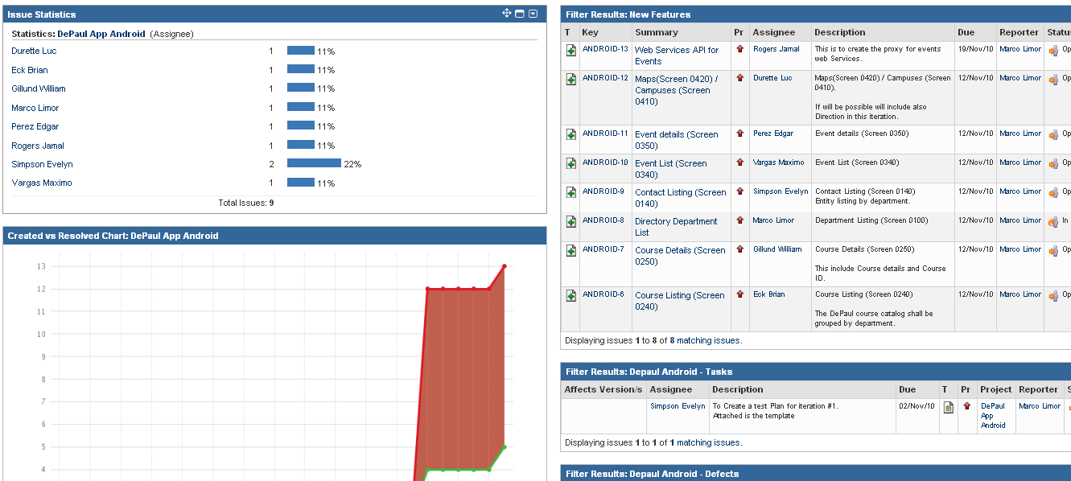

Reports
The Test lead will be responsible for writing and disseminating the following reports to appropriate project personnel as required.

Testing status reports
A weekly or bi-weekly status report will be provided by the Test Lead to the team. This report will summarize weekly testing activities, issues, risks, bug counts, test case coverage, and other relevant metrics.

Phase Completion Reports
When each iteration of testing is completed, the Tester will distribute a Iteration Completion Report to the Product manager, Development Lead, and Program Manager for review and sign-off.
The document must contain the following metrics:
- Total Test Cases, Number Executed, Number Passes / Fails, Number Yet to Execute
- Number of Bugs Found to Date, Number Resolved, and Number still Open
- Breakdown of Bugs by Severity / Priority Matrix
- Discussion of Schedule Progress (are we where we are supposed to be?)

Test Final Report - Sign-Off
A Final Test Report will be issued by the Tester. It will certify as to the extent to which testing has actually completed (test case coverage report suggested), and an assessment of the product’s readiness for Release to Production.

Responsibility Matrix

Name | Role
Limor Marco | Project Manager/Developer
Denise Simpson | Developer/Test Lead
Brian Eck | Developer/ Tech Lead
Bill Gillund | Developer/Tester
Maximo Vergas | Developer/Tester
Edgar Perez | Developer/Tester
Luc Durette | Developer/Tester
Jamal Rogers | Developer/Tester

Resource & Environment Needs

Testing Tools

Tracking Tools
JIRA bug tracker is used to enter and track all bugs and project issues.

Configuration Management

- Google Code and Subversion are being used as configuration management tool.
- Hudson server for continues builds and Junit auto testing.

Test Environment

Hardware
Phase and final testing will be conduct on a Android unit .

Software
In addition to the application and any other customer specified software, the following list of software should be considered a minimum:
- Window XP, Vista or Mac OS.
- MS Office Professional
- Eclipse and Plugins
- Hudson server for continues build support.

Bug Severity and Priority Definition
Bug Severity and Priority fields are both very important for categorizing bugs and prioritizing if and when the bugs will be fixed. The bug Severity and Priority levels will be defined as outlined in the following tables below. Testing will assign a severity level to all bugs. The Test Lead will be responsible to see that a correct severity level is assigned to each bug.

The Test Lead, Development Lead and Program Manager will participate in bug review meetings to assign the priority of all currently active bugs. This meeting will be known as “Bug Triage Meetings”. The Test Lead is responsible for setting up these meetings on a routine basis to address the current set of new and existing but unresolved bugs.

Severity List
The tester entering a bug into GForge is also responsible for entering the bug Severity.

Severity ID | Severity Level | Severity Description
1 | Blockers | The module/product crashes or the bug causes non-recoverable conditions. System crashes, GP Faults, or database or file corruption, or potential data loss, program hangs requiring reboot are all examples of a Sev. 1 bug.
2 | Critical | Critical system component unusable due to failure or incorrect functionality. Sev. 2 bugs cause serious problems such as a lack of functionality, or insufficient or unclear error messages that can have a major impact to the user, prevents other areas of the app from being tested, etc. Sev. 2 bugs can have a work around, but the work around is inconvenient or difficult.
3 | Major | Incorrect functionality of component or process. There is a simple work around for the bug if it is Sev. 3.
4 | Minor | Documentation errors or signed off severity 3 bugs.

Priority List
Priority ID | Priority Level | Priority Description
1 | Must Fix | This bug must be fixed immediately; the product cannot ship with this bug.
2 | Should Fix | These are important problems that should be fixed as soon as possible. It would be an embarrassment to the company if this bug shipped.
3 | Fix When Have Time | The problem should be fixed within the time available. If the bug does not delay shipping date, then fix it.
4 | Low Priority | It is not important (at this time) that these bugs be addressed. Fix these bugs after all other bugs have been fixed.
5 | Trivial | Enhancements/ Good to have features incorporated- just are out of the current scope.

Bug Reporting

The Test Lead will be responsible for managing the bug reporting process. Testing’s standard bug reporting tools and processes will be used. JIRA is the team-wide standard Bug Logging / Tracking tool. Testing and development will enter their data into the JIRA database following the field entry definitions defined below.

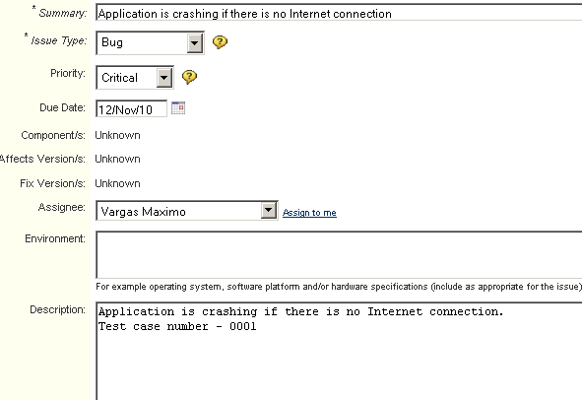

Terms/Acronyms
TERM/ACRONYM | DEFINITION
API | Application Program Interface
CAT | Client Acceptance Testing
End-to End Testing | Tests user scenarios and various path conditions by verifying that the system runs and performs tasks accurately with the same set of data from beginning to end, as intended.
N/A | Not Applicable
QA | Quality Assurance
RTM | Requirements Traceability Matrix
SME | Subject Matter Expert
TBD | To Be Determined
TSR | Test Summary Report

